**Level Crossing Automatic Barrier**

# 

# Abstract: -

The aim of this project is to streamline and automate the operation of gates at railway level crossings, a task traditionally reliant on manual gatekeepers. These gatekeepers receive train arrival information from nearby stations, and when a train departs from the station, the station in- charge communicates this information to the nearest gatekeeper to prepare for gate closure. However, this human-centrist process can be eliminated through automation, resulting in more efficient and reliable gate management.

One significant issue with the manual system is that when trains are delayed for various reasons, the gates may remain closed for extended periods, leading to severe traffic congestion near the level crossings. This problem can be mitigated by introducing automation to the gate operation process. The proposed system leverages infrared (IR) sensors in combination with an Arduino control system to detect and respond to the presence of trains at the railway level crossing.

The core functionality of this automated system relies on the utilization of two IR sensors, strategically positioned to monitor the arrival and departure of trains. The gate remains in the closed position until the entire train has passed through the crossing, ensuring safety, and preventing any premature gate reopening. Once the train has completely cleared the level crossing, the motor engages to open the gate.

This innovative system represents a significant advancement in the automation of gate operations at railway level crossings. By eliminating the need for human gatekeepers and integrating IR sensors with an Arduino control system, the proposed solution ensures a seamless and efficient process for managing level crossing gates. It addresses the problem of gates being closed for extended duration due to train delays, thus alleviating traffic congestion and enhancing safety.

In conclusion, the project's primary goal is to optimize and automate gate operations at railway level crossings, promoting efficiency and safety while reducing reliance on manual intervention. The use of IR sensors in conjunction with an Arduino control system achieves the desired level of automation, ensuring that gates are only opened when it is safe to do so. This technological advancement offers a promising solution to the challenges associated with traditional gate management methods, ultimately enhancing the overall railway crossing experience for both commuters and operators.

# Motivation towards Problem Statement: -

The motivation behind the proposed solution for a level crossing automatic barrier system stems from a deep-seated concern for safety and efficiency in railway operations. The existing manual gatekeeper system, which relies on human intervention to manage level crossings, is inherently susceptible to human errors and inconsistencies. This motivation arises from a strong desire to eliminate these risks, thereby reducing the potential for accidents and mishaps at railway crossings. The safety of both road users and train passengers is of paramount importance, and automating barrier operations is a proactive step toward achieving this safety goal.

Furthermore, the motivation for this solution is driven by the need to address the issues of traffic congestion and delays that often plague level crossings. The system's ability to accurately detect and respond to train movements ensures that barriers are lowered only when necessary, reducing unnecessary wait times for motorists and pedestrians. By streamlining the operation of level crossings, the proposed solution aims to enhance the overall efficiency of railway transportation, benefiting both commuters and the railway industry.

Lastly, the motivation is underpinned by a commitment to modernizing railway infrastructure and aligning it with the advancements in automation and technology. Embracing automation in the railway sector not only improves safety and efficiency but also brings rail transportation in line with contemporary smart transportation systems. This motivation for progress and innovation reflects a broader commitment to continually improve the transportation experience for all stakeholders and contribute to a safer, more streamlined, and technologically advanced railway network.

# Problem statement: -

Issue report surrounding manual operation of overcharged gates and related challenges. Currently, access controllers rely on train information coming from neighboring stations, leading to delays and the risk of human error. In the event of a train delay, the doors may remain closed for long periods of time, causing traffic congestion and safety risks. The main problem is to develop an automated system that eliminates human intervention. The system is expected to effectively detect incoming and outgoing trains, ensuring doors open and close quickly and accurately. The proposed solution aims to use infrared sensors and Arduino technology to achieve this automation, thereby minimizing the risks and inconveniences caused by current manual gate control systems.

Railway level crossings present a significant challenge in terms of safety and operational efficiency. The existing manual operation of level crossing gates, managed by gatekeepers who rely on information from nearby stations, is prone to human error and inefficiencies. The primary problem lies in the dependency on human intervention for gate operation. Human gatekeepers must be informed of train arrivals and departures, leading to potential delays and miscommunications. This reliance on manual labor not only makes the process susceptible to error but also results in inefficiencies, especially when trains are delayed for various reasons, causing gates to remain closed for extended durations and leading to traffic congestion.

Another critical issue with the current system is the potential for accidents at level crossings due to human oversight or misjudgment. In high-traffic areas, the risk of collisions between vehicles and trains is a significant concern. Furthermore, when barriers remain down unnecessarily due to delayed trains, it causes frustration among commuters and gridlock on roadways, impacting both safety and traffic flow.

The proposed solution for an automatic barrier system at railway level crossings aims to address these problems by introducing automation and advanced sensor technology. By replacing human gatekeepers with automated sensors and intelligent control systems, the proposed solution not only enhances safety but also streamlines the operation of level crossing barriers, reducing the potential for traffic congestion and accidents. The integration of train presence detection sensors, vehicle and pedestrian sensors, and communication systems ensures that barrier movements are synchronized with train schedules and prioritize safety, ultimately leading to a more efficient and secure railway crossing experience for all stakeholders.

# Proposed Solution: -

The proposed solution for a level crossing automatic barrier represents a significant step forward in enhancing safety and efficiency at railway crossings. By automating the operation of barriers, this system reduces the potential for human error, ensuring that barriers are deployed precisely when necessary to prevent accidents. The central component of the solution is a robust barrier mechanism designed to withstand environmental conditions and effectively block access to railway tracks. This barrier is controlled by an intelligent unit that receives input from a network of sensors, allowing for real-time monitoring and responsive action.

The system employs an array of sensors, including train presence detection sensors, vehicle and pedestrian sensors, and communication capabilities. Train presence sensors scan the tracks for approaching trains, signaling the control unit to initiate the barrier lowering process. Vehicle and pedestrian sensors are strategically positioned on the road or walkway, ensuring the system's responsiveness to potential obstructions. The integration of communication features allows for the synchronization of traffic signals, alerting train operators and central control systems, and even communicating with nearby vehicles, promoting a safer railway environment.

Furthermore, the inclusion of a backup power source ensures system reliability even during power outages, a vital safety feature. Safety measures, such as warning lights, bells, and cross bucks, work in concert with fail-safes to prevent accidents at level crossings. Continuous monitoring and maintenance systems are integrated, allowing for proactive upkeep and immediate repairs, maintaining system functionality. Ultimately, this solution not only advances safety but also contributes to the optimization of the broader railway network by minimizing delays and enhancing the flow of both road and rail traffic.

# Block Diagram/flow chart: -

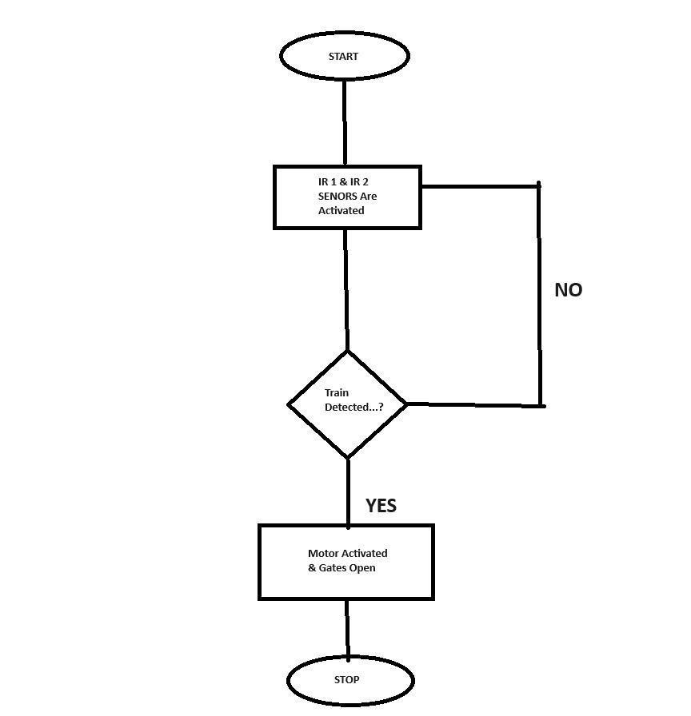

# Simulation Diagram: -

# 

# Working: -

The proposed work focuses on the development of automatic gate systems for railway crossings to address the challenges associated with manual gate operations. This system harnesses the power of modern technology to ensure ships and vehicles move quickly and safely.

The system includes a network of sensors, controllers, and gate actuators to achieve automation. Two infrared (IR) sensors are strategically placed on either side of the track, a few meters from the level crossing. These sensors act as the eyes of the system. When a train approaches, the first infrared sensor detects its presence and transmits the information to the controller, an Arduino micro controller. The controller will then trigger the closing of the crossing gate to prevent vehicles from crossing the tracks. The door remains closed until the train has completely moved out of the junction, as detected by the second infrared sensor.

The Arduino micro controller plays a central role in the operation of the system. It processes sensor data and controls gate motors. It is programmed to ensure that the door remains closed while the train passes, thus ensuring the safety of rail and road users. Once the second sensor registers the train's departure, the Arduino will quickly activate the gate motor to open the gate, allowing traffic to continue.

In addition to basic functionality, the system can be equipped with communications capabilities to relay real-time information to nearby stations and monitoring centers. This feature can help manage overall rail traffic effectively, ensuring that trains and road vehicles can move safely at intersections.

The advantages of this automated system are many. It eliminates the need for manual access controllers, reducing labor costs and the risk of human error. Additionally, it ensures that the doors open and close quickly, thereby reducing traffic congestion and improving safety at level crossings. The system is adaptable and can be integrated into existing rail infrastructure, making it an efficient and cost-effective solution.

# Components: -

* Arduino Board
* Servo Motor
* IR Sensors
* Toy Train
* Jumping Wires
* Cardboard

# Photograph of the prototype: -

# 

# Fig: - 1 Prototype

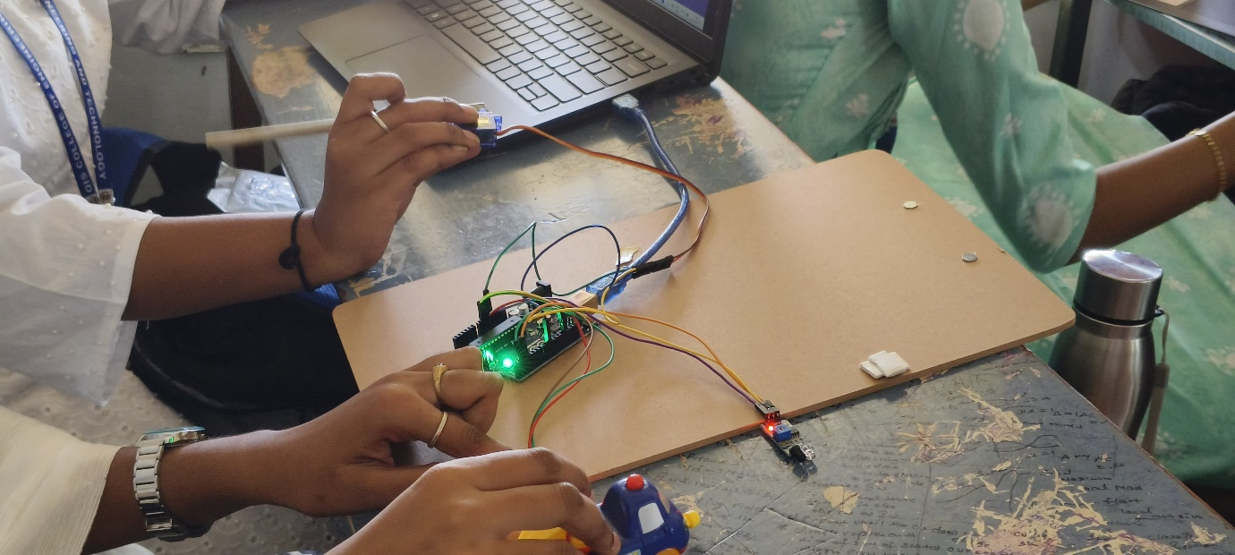**Fig: -2** When the first IR sensor detects the gate opening

Fig: - 3 When the second IR sensor detects the gate close

# Conclusion: -

The proposed horizontal gate automation system, using infrared sensors and Arduino technology, offers a promising solution to improve railway efficiency and safety. By replacing manual controls with sensors and automatic control systems, human error is reduced and the risk of accidents at level crossings is minimized. The successful implementation demonstrates its feasibility for wider adoption across the rail network.